PROJECT PROPOSAL

NIHVA TECHNOLOGIES PVT. LTD.
187, G-Block, Thermax chowk, Above Renault Showroom, MIDC
Chinchwad, Pune – 411019.

Contact Person: Mr. Mayur Derle
Mob No.: 7709209333
Web: http://www.nihva.com

AUTOMATION SOLUTION-DIVISION

Ordnance Factory

Title: Automation Of 16 mm Cartridge
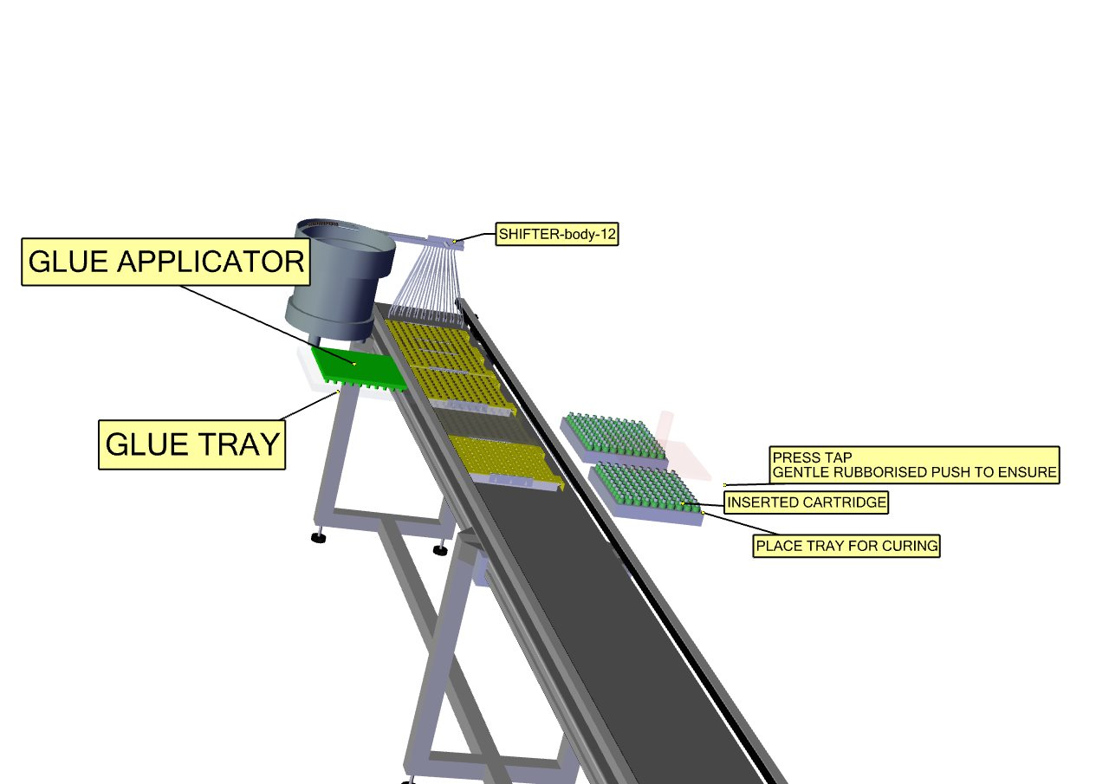

Date: 04.09.2017

To,

Ordnance Factory
Dehuroad, Pune-412101

Kind Attention: Mr. T.K. PANDA

Dear Sir,

Thank you for giving us an opportunity to participate with our offer on the above project. We enclose here with our proposal includes:

- Requirement
- Scope of Works
- Drawing, Training & warranty
- Details of Application
- Commercial
- Technical Specification
- Terms & conditions

- Requirement
- Energy efficient Design: The system should be energy efficient. The design shall ensure minimum possible power.
- Reduced Manpower: In this process only few things are done by workers and all the heavy operation will have done by machine automatically. So this system will require minimum labour work.

- Scope of work:

The scope of work shall be exclusively on Automation of 16 mm Cartridge
For the above scope, following set of activities are expected to be performed:

- Machine 1

- In Machine 1 RF Caps will fed to bowl feeder and then passed it linearly through linear feeder each 10 set of caps will pick by picker & tilted it to 90 deg. Drop araldite on it then transfer it to the tray and that filled tray will passed through conveyor. & leave it for 24hrs

- Machine 2

- After 24 hrs. the cartridge will exchange manually from one tray to another to make cavity towards upside.
- After that gun powder G40 & G90 will fill to the 100 cartridges at a time.
- After that Star pieces will fed to the bowl feeder and linear feeder and then to tray. By using Visual system, we can make sure the bottom of star should be on upside.
- Then apply APC 217 on star face. After that this tray will inverted into gun powder fed cartridge tray.
- After that Cardboard sheet will passed through bowl Feeder after that apply araldite
On both side of cardboard and then insert it into each cartridge.

- Machine 3

- After that index disc will pass through Bowl feeder and place above the cardboard sheet maintaining hill towards upside.

NIHVA Automation Services Scope of supply:

Includes following:

- Design
- Manufacturing
- Successful Trails at our end
- Dispatch at your ends.
- Installation & Commissioning @ ORDNANCE FACTORY DEHURAOD
- Operator & Maintenance Training.
- Warranty of the equipment for 1 year from commissioning date.
- Hard & Soft Copy of Operator & Maintenance Manual.

- Drawing:

We will issue a full set of shop drawings for approval within 2 weeks of receiving the confirmed
order and finalized design details.

- Training:

After installation of the automation system, we will train the Clients personnel in the operation and basic maintenance, including the understanding of the error codes on the control system (if applicable).

- Warranty:

The warranty period is twelve months from the date of installation and commissioning.

If a defect arises within the warranty period stated, which is attributable to faulty design,
materials or installation workmanship the product will be repaired at our discretion without
charge. This guarantee is subject to proper use of the product and assumes that the product is
regularly serviced and maintained by skilled personnel in accordance with the operation and
maintenance instructions supplied.

- Maintenance & Service Agreement:

We would suggest that you take advantage of a maintenance and service agreement on the NIHVA products, which will guarantee trouble free operation and speed of response in an emergency. Customized proposals are available on request

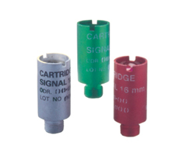
- Details of Application:

- Components Details

- Work piece Description: - Shell & Tail
- Weight: - 4 kgs approx.
- Diameter: -81 mm

Cartridge signal 16 mm Red/Green/White

- Commercial:

Boat Tail Assembly

Sr. No |  | Description |  |  |  | Qty | Price in  INR/Each | Total Amount  In INR
Machine 1  Servo Motor Drive ,Make: Panasonic |  |  |  |  |  | 1 | 26,00,000 | 26,00,000
1. |  | Bowl Feeders |  |  |  | 1 | 26,00,000 | 26,00,000
2. |  | Pick & Place Machine |  |  |  | 1 | 26,00,000 | 26,00,000
3. |  | Outward Assembly |  |  |  | 1 | 26,00,000 | 26,00,000
4. |  | Glue Placer system |  |  |  | 1 | 26,00,000 | 26,00,000
Machine 2
1. |  | Conveyor |  |  |  | 1
2. |  | Volume Filter assembly |  |  |  | 1
3. |  | Candle Insertion System |  |  |  | 1
4. |  | Vision System |  |  |  | 1 | 55,00,000 | 55,00,000
5. |  | Card Board Sheet Placer & Linear Feeder Assembly |  |  |  | 1 | 55,00,000 | 55,00,000
6. |  | Star Placer linear & Glue placer |  |  |  | 1 | 55,00,000 | 55,00,000
7. |  | Plc, Sensors & Control System |  |  |  | 1 | 55,00,000 | 55,00,000
Machine 3
1. |  | Index Disc Placer |  |  |  | 1 | 14,00,000 | 14,00,000
2. |  | Glue Placer Assembly |  |  |  | 1 | 14,00,000 | 14,00,000
3. |  | Installation Charges for Above System |  |  |  | 1 | 2,000 | 2,000
4. |  | Transportation Charges for Above System |  |  |  | 1 | 15,000 | 15,000
 |  | Total Amount |  |  |  |  |  | 95,17,000

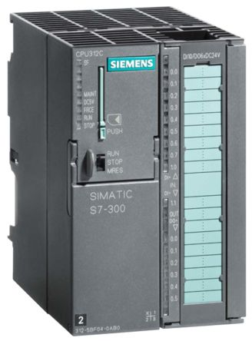
- Technical Specification :

- PLC & HMI
Make – Siemens / Schneider

- Motor 1 HP/ 2 HP

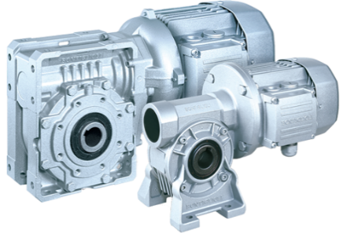
Make – Sew / Crompton/ Bonfiglioli

Bowl Feeder & Linear Feeder

Make – Nihva

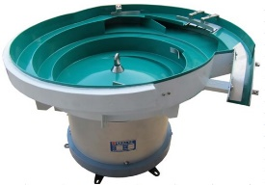

Conveyor System

Make – Nihva

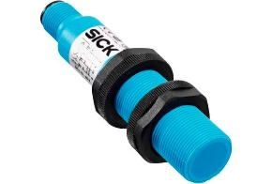

Proximity Sensors, Make – Sick

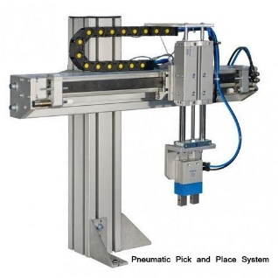

Pick & Place Machine

Make – Nihva

Pneumatic Cylinder

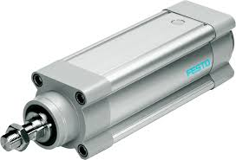
Make – SMC / Festo


Vision System

Make – As suitable

- Safety features

- In case of sudden power cut off, system will stand as it is until reset.
- FEA will be conducted for critical elements.
- Secondary Safety chain catch to prevent accidental drop off.
- Test Certificate will be provided for whole system.

- Terms and Conditions:
- Price : Ex. Works Pune
- P & F Charges : Included in above prices.
- Freight Notes : Included in above prices.
- Delivery : within 9-10 weeks from the date of receipt of confirmed purchase order, Advance Payment, Drawing approval.
- Payment :80% Advance along with Confirmed Purchase Order & Balance before dispatch.
- Insurance : Extra as applicable.
- Tax: GST : 28% on total supply value. (as applicable)
- Validity :15 days from the date of quotation.
- Warranty :12 Months from the date of supply.
Please feel free to Contact Mr. Mayur Derle on 7709209333 For any further Clarification in this Concern.

With Best Regards
Pooja Badre
7709586333
For NIHVA Technologies Pvt Ltd

